Laboratory Tutorial#3
1. Objective: Open loop vs closed control of speed of a D.C motor.
2. Equipment Required: Following equipment is required to perform above task.
Quantity Apparatus
1 OU150A Operation Amplifier Unit
1 AU150B Attenuator Unit
1 SA150D Servo Amplifier
1 PS150E Power Supply
1 MT150F Motor-Tacho Unit
1 LU150L Load Unit
3. Approximate Time Required: One to two Hours
4. Discussion
Referring back to Laboratory Tutorial on motor characteristics, we have developed a curve of signal input to the servo-amplifier against speed. This means without any load you can set the motor to run at a specified speed by determining the value of input signal. With an open loop system there can be reasonable speed control when operating without load or with a fixed load. But the open loop system would be very unsuitable if a variable load is connected to motor shaft.
In this practical we are going to show the improvement that can result from closing the loop and using feedback. That is, the actual speed will be compared with required speed. This produces an error signal to actuate the servo-amplifier output so that the motor maintains a constant speed.
5. Experimental Set Up
As a first experiment we will operate the motor in open loop under constant and variable load conditions. The patch diagram for open loop speed control is given in figure-1. Table-1 can be used here to analyze the performance of the system under variable load conditions.
In next experiment we will simply feedback a signal proportional to the speed, using the Tachogenerator. We then compare it with a reference signal of opposite polarity, so that the sum will produce an error signal proportional to the difference between reference speed and actual speed of the motor. The patch diagram of the simple closed loop speed control of a DC motor is shown in figure-2.
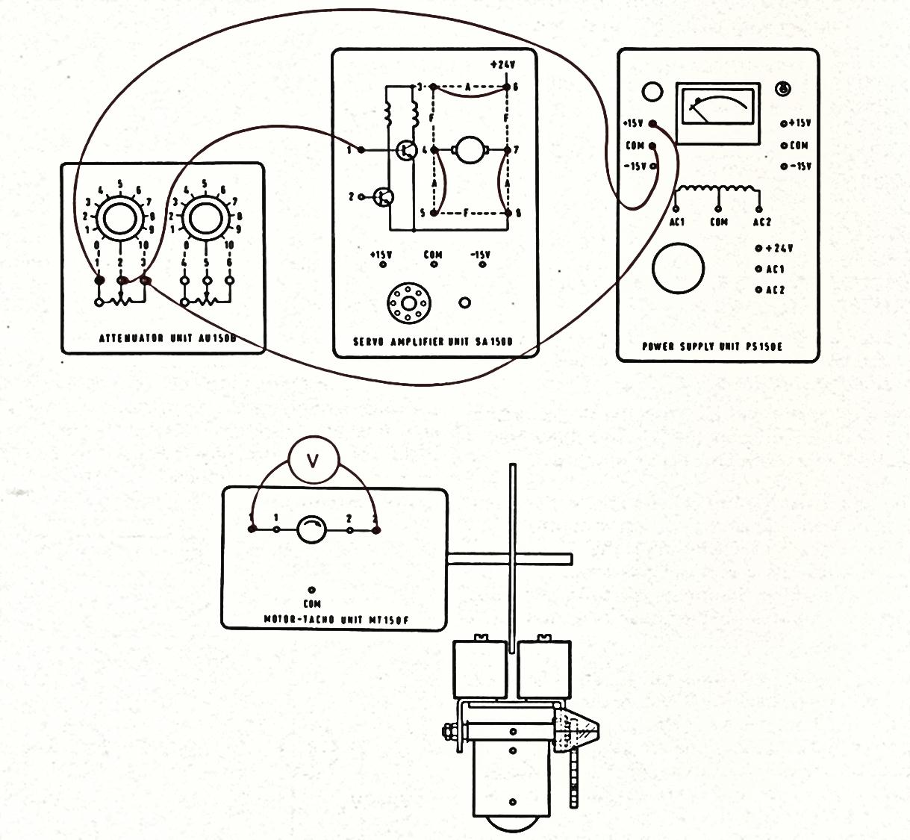
Figure-1: Experimental set up (Armature Control Mode)
S.No | Tachogenerator volts (V_{g}) | V_{in} |  | No. of rotations of low Speed Shaft (a) |  | Speed in  rev/min  N=30×a
Table-1: Armature control d.c Motor Speed characteristics
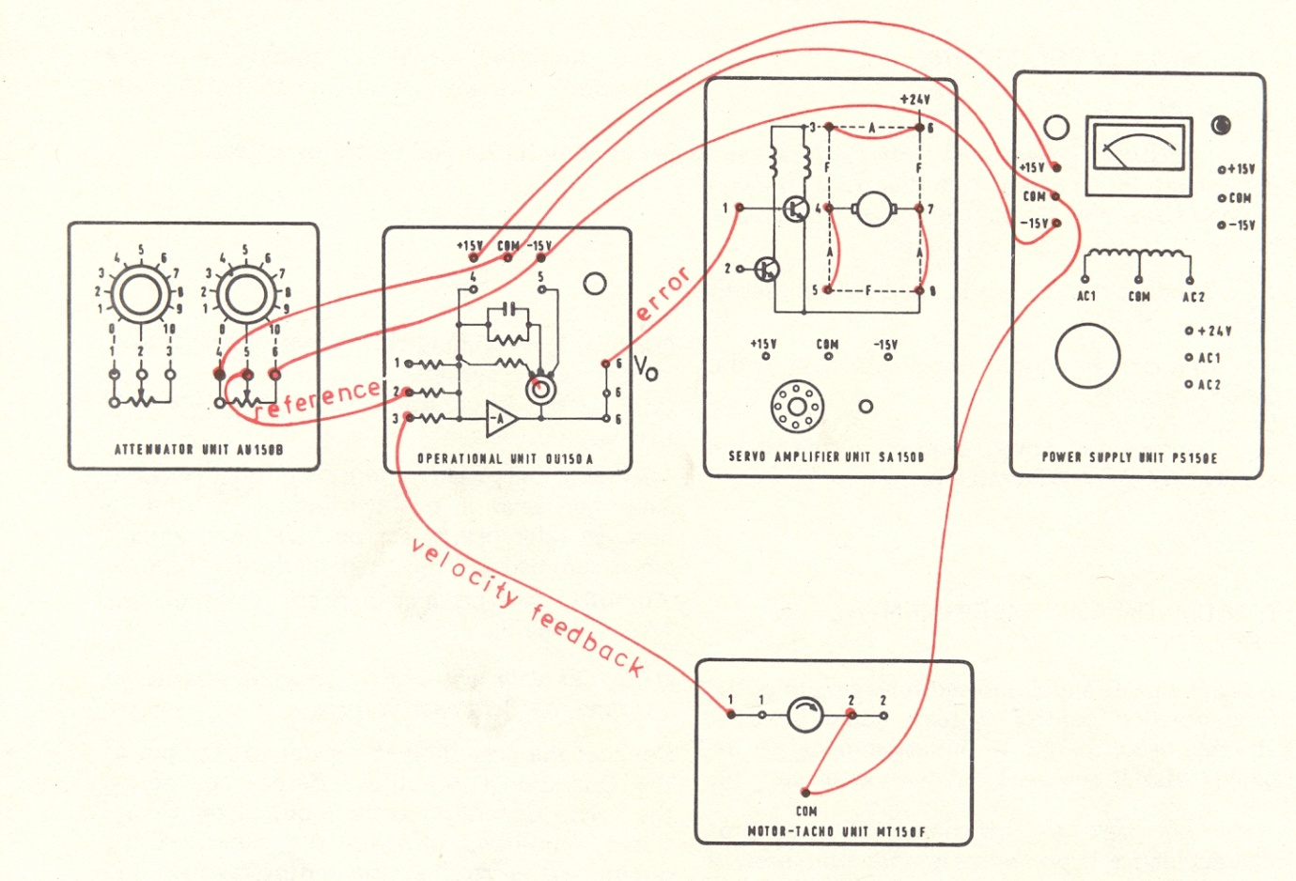
Figure-2: Simple Closed Loop Speed Control of a DC Motor
Connect the potentiometer slider to an input of the operational amplifier. To find out the effect of load on speed we can use the magnetic brake as a load.
S.No | Reference Voltage | Tachogenerator Voltage | Error Voltage | Speed rev/min
Table-2: Closed Loop Speed Control
6. Conclusion

