**Lab-6: Control System Toolbox**

**Objectives:** To become familiar with following

1. Mathematical modeling in using control system toolbox
2. Reduction of complicated block diagram using Control system toolbox
3. Time domain analysis of control system
4. Frequency domain Analysis of control systems
5. Root locus analysis of control system

**Equipment Required:** Personal Computer, Matlab R2007 or later.

**Exercise-1:** Simplify the following block diagram and determine the following (Assume K=10).

* 1. Closed loop transfer function (C/R)
  2. Poles
  3. Zeros
  4. Pole-zero-map

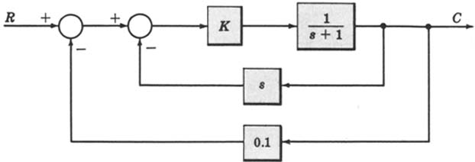



**Exercise-2:** Simplify the following block diagram and determine the following.

* 1. Closed loop transfer function (C/R)
  2. Poles
  3. Zeros
  4. Pole-Zero-map

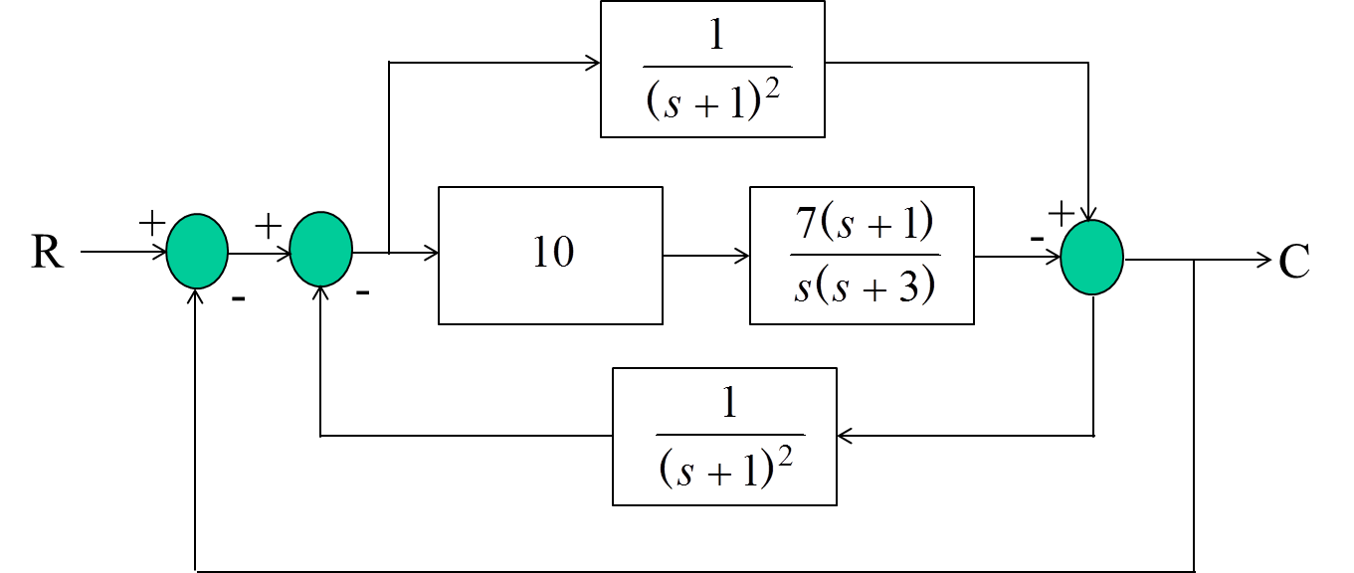

**Exercise-3:** Obtain the step and ramp responses of the following 1st order system for T=1, 2, 3 5, 10 seconds.



**Exercise-4:** Obtain the step and ramp responses of the following 1st order system for K=1, 5, 10 and 15.



**Exercise-5:** Obtain the step response of the following 1st order system with zero for

1. K=1, α=4 and T=3 sec



1. K=1, α=3 and T=4 sec
2. K=1, α=3 and T=3 sec
3. And compare the results with system w/o zero

**Exercise-6:** Describe the nature of the second-order system response via the value of the damping ratio for the systems with transfer function



**Exercise-7:** Obtain the pole zero map and step response of the 2nd order system and determine the mode of damping in the system. If the system is underdamped obtain the time domain specifications. On the pole zero map show that corresponding damping ratio and natural undamped frequency of the poles.

1. ωn=3 r/s and ζ=1
2. ωn=3 r/s and ζ=2



1. ωn=3 r/s and ζ=0.1
2. ωn=3 r/s and ζ=0.5
3. ωn=3 r/s and ζ=0

**Exercise-8:** Obtain the step response of the 2nd order system if

1. ωn=0.1 r/s and ζ=0.5



1. ωn=0.3 r/s and ζ=0.5
2. ωn=0.6 r/s and ζ=0.5
3. ωn=1 r/s and ζ=0.5
4. ωn=1.5 r/s and ζ=0.5

**Exercise-9:** Consider the system shown in following figure, where damping ratio is 0.6 and natural undamped frequency is 5 rad/sec. Obtain the rise time tr, peak time tp, maximum overshoot Mp, and settling time 2% and 5% criterion ts when the system is subjected to a unit-step input.

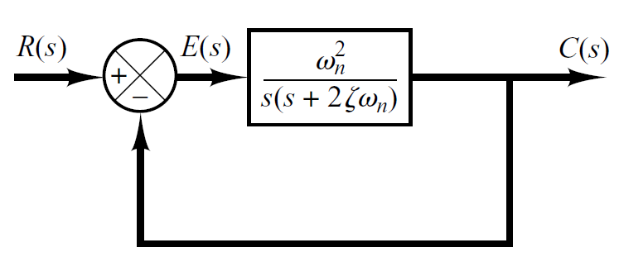

**Exercise-10: -** Obtain the bode plot of the second order system

ωn = 0.1 rad / sec and ζ = 0.1, 0.5, 1, 1.5

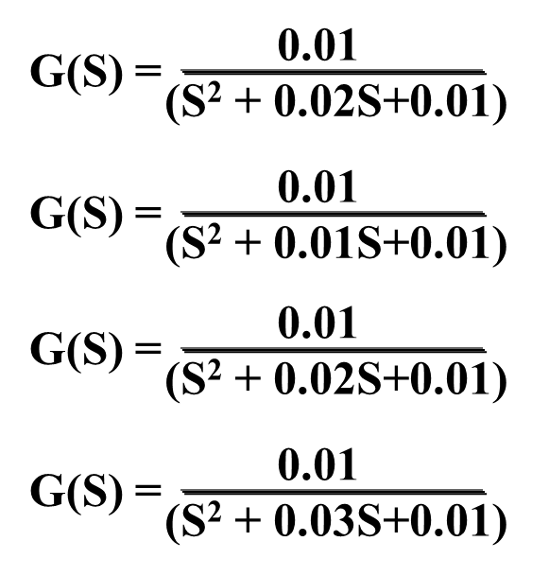

**Exercise-11: -** Calculate the magnitude and phase of the following system at *w (rad/sec)*=0.1, 0.5, 1, 10, 100.



**Exercise-12: -** Consider following transfer function



1. Obtain the Nyquist plot of the following system (when w>0).
2. Determine the open-loop & closed-loop magnitude responses when w=2.5 rad/sec

**Exercise-13: -** For the following Transfer Function



1. Obtain the Nichols Chart
2. Determine the open-loop as well as closed-loop magnitude and phase when w=1.39 rad/sec.

**Exercise-14:-** Obtain the phase and gain margins of the system shown in following figure for the two cases where K=10 and K=100.

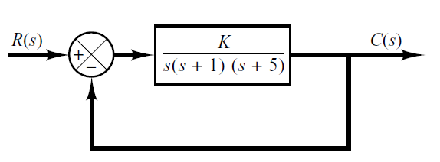

**Exercise-15:-** Consider the system shown in following figure. Obtain Bode diagram for the closed-loop transfer function. Obtain also the resonant peak, resonant frequency, and bandwidth.

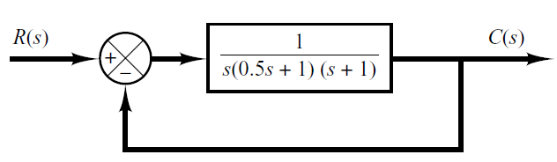

**Exercise-16:-** Plot the root locus of following first order systems.

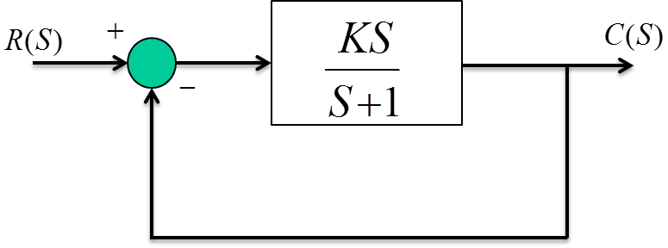

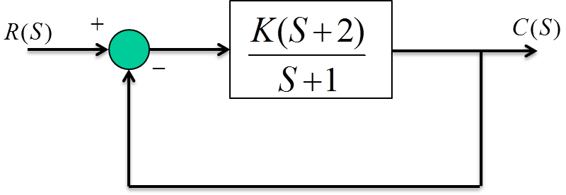

**Exercise-17:-** Plot the root locus of following 2nd order systems.

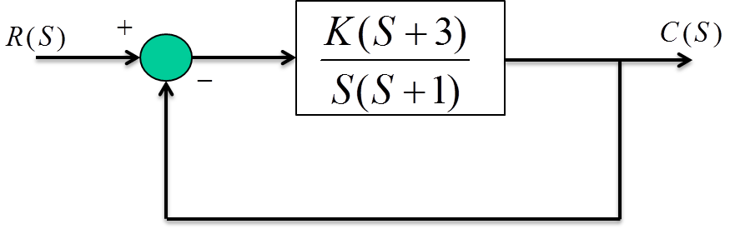

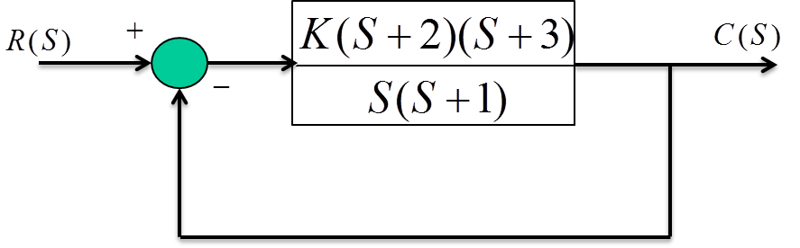

**Exercise-18:-** Plot the root locus of following 2nd order systems.

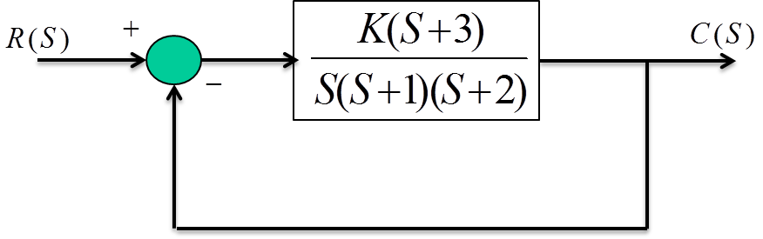

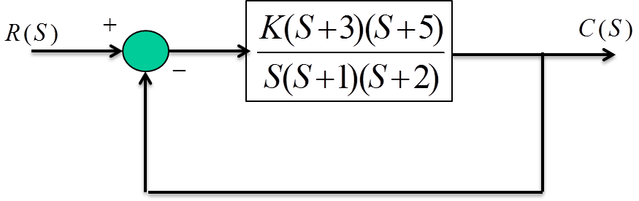

**Exercise-19:-** Plot the root Loci for the above ZPK model and find out the location of closed loop poles for ς=0.505 and ωn=8.04 r/sec.



**Exercise-20:-** Consider the following unity feedback system



1. Plot the root Loci for the above transfer function
2. Find the gain when both the roots are equal
3. Also find the roots at that point
4. Determine the settling of the system when two roots are equal.

**Exercise-21:-** Consider the following velocity feedback system

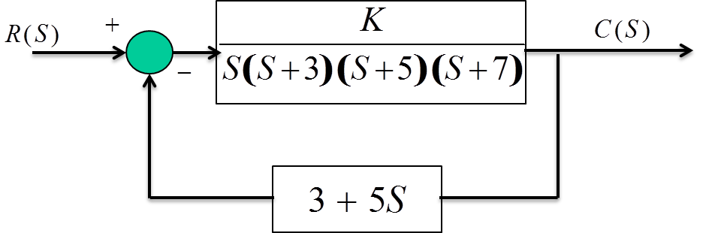

1. Plot the root Loci for the above system
2. Determine the gain *K* at which the system produces sustained oscillations with frequency 8 *rad/sec*.